DATA SCIENCE TOOLBOX: PYTHON PROGRAMMING
PROJECT REPORT
(Project Semester January-April 2025)

Bihar Air Quality Analysis

Submitted by

Puja Kumari

Registration No. 12315500

Programme and Section:
Course Code. INT 375

Under the Guidance of

Dr. Karan Bajaj (32130)

Discipline of CSE/IT

Lovely School of Computer Science and Engineering
Lovely Professional University, Phagwara

DECLARATION
I, Puja Kumari, student of Bachelors of Technology under CSE/IT Discipline at, Lovely Professional University, Punjab, hereby declare that all the information furnished in this project report is based on my own intensive work and is genuine.

Date: 11 April, 2025 Signature
Registration No. 12315500 Name of the student: Puja Kumari

CERTIFICATE
This is to certify that Puja Kumari bearing Registration no. 12315500 has completed INT 375 project titled, “BIHAR AIR QUALITY ANALYSIS” under my guidance and supervision. To the best of my knowledge, the present work is the result of his/her original development, effort and study.

Signature and Name of the Supervisor
Designation of the Supervisor
School of Computer Science and Engineering
Lovely Professional University
Phagwara, Punjab.

Date: 12.04.025

ACKNOWLEDGEMENT
I wish to extend my deepest appreciation to my teachers for their exceptional guidance and steadfast support throughout this journey. Their passion for teaching and commitment to my development have greatly shaped my knowledge and enthusiasm for learning. Their encouragement has instilled in me the confidence and resolve to chase my ambitions with determination, and for that, I am truly thankful.
I also owe a great deal of gratitude to my friends, whose constant encouragement and companionship have made this experience both rewarding and enjoyable. Their unwavering belief in me, coupled with their insightful perspectives and engaging conversations, has motivated me to stretch my limits and aim for excellence in every task and hurdle I encountered.
Moreover, I am profoundly grateful to my family for their endless love and inspiration. Their unshakable faith in my potential has been my strongest driving force, giving me the resilience to navigate challenges and persist through tough moments. Their support has been a cornerstone of my efforts, and I cannot thank them enough.
Lastly, I extend my sincere thanks to everyone who has stood by me as pillars of strength and believed in my abilities at every turn. Your collective contributions have played an invaluable role in shaping me into the individual I am today, and I will always cherish your impact on my life.

TABLE OF CONTENTS

1. Introduction 6
2. Source of Dataset 7
3. EDA Process 8
4. Analysis on Dataset 11
5. Conclusion 21
6. Future Scope 23
7. References 24

1. Introduction
The health and well-being of communities are deeply intertwined with the quality of their air, making air pollution analysis a critical tool for public health, policy formulation, and environmental stewardship. Air quality data serves as a barometer for industrial activity, urbanization, and the effectiveness of regulatory measures, reflecting broader socio-economic and environmental trends. By examining metrics such as pollution levels, healthcare facility distribution, and their correlations, stakeholders—ranging from government agencies to healthcare providers—can identify high-risk areas, allocate resources efficiently, and design targeted interventions to mitigate health risks.
This report presents a comprehensive analysis of air quality and healthcare infrastructure data in Bihar, leveraging Python's powerful data science ecosystem to extract actionable insights. The dataset encompasses key indicators such as the distribution of healthcare facilities (categorized as allopathic, ayurvedic, homeopathic, siddha, and Unani), along with their associated doctor counts, offering a unique lens into regional healthcare capacity and its potential relationship with environmental factors.
The primary objective of this project is to transform raw data into clear, visual narratives that highlight disparities, trends, and opportunities for intervention. Using libraries like Pandas for data wrangling, Matplotlib and Seaborn for visualization, and NumPy for statistical analysis, this study employs rigorous exploratory data analysis (EDA) to clean, validate, and interpret the dataset. The analysis culminates in a suite of visualizations—including bar charts, pie charts, and geographical distributions—that collectively reveal:
- Regional disparities in healthcare access, pinpointing underserved areas.
- Pollution-linked health risks, inferred from facility density and type.
- Policy-ready insights, such as prioritizing regions with low doctor-to-population ratios or high reliance on traditional medicine.

Structured for clarity, this report begins with an overview of the dataset, proceeds through methodological details of the EDA, and synthesizes findings into actionable conclusions. Each visualization is designed to balance analytical depth with accessibility, ensuring relevance for diverse audiences, from policymakers to researchers. By bridging data and decision-making, this work aims to contribute to healthier communities and more resilient healthcare systems in Bihar

2. Source of Dataset

The dataset for this analysis, titled "Bihar Air Quality Analysis," was sourced from the Government of India’s open data portal at https://data.gov.in. It was accessed through a search query using the keywords “Bihar air quality analysis” (search results: https://www.data.gov.in/search?title=bihar%20air%20quality%20%20analysis&type=resources&sortby=_score). This platform provides official datasets from various government departments, ensuring the data’s credibility and authenticity.

The dataset contains information on air quality levels across multiple districts in Bihar, along with healthcare infrastructure details. It includes key environmental indicators such as levels of pollutants (e.g., PM2.5, PM10, NO2), helping to assess the air quality in both urban and rural areas of the state. Alongside this, the dataset covers healthcare facility data, categorized by system type: allopathic, ayurvedic, homeopathic, siddha, and Unani.

Maintained by relevant government departments, the dataset includes critical metrics such as the number of doctors per facility, enabling an understanding of healthcare accessibility across different regions. This combination of environmental and health-related data makes the dataset a valuable resource for analysing the impact of air quality on public health and the readiness of healthcare services to respond to related issues.

The data is available in structured formats like CSV or Excel, which integrate well with tools like Microsoft Excel or Python libraries such as Pandas. This makes it easy to clean, manipulate, and analyse the information for various research or policy-related purposes.

Spanning multiple years, this dataset captures trends and changes in Bihar’s environment and health infrastructure. It reflects broader patterns like increasing urbanization, seasonal pollution peaks, and ongoing efforts to strengthen medical services. The district-level granularity allows for deep insights into both environmental and healthcare inequalities across the state.

After downloading the dataset, I verified its structure and contents to ensure it matched the scope needed for this project. Choosing this dataset allowed for a comprehensive, region-specific analysis that connects air quality conditions with healthcare readiness—a critical intersection in public policy and planning.

In summary, this Bihar-specific dataset from the Government of India’s open data portal is a reliable and detailed source. It supports in-depth exploration of environmental and healthcare trends, making it ideal for understanding regional challenges and opportunities in public health management.

3. EDA Process
Exploratory Data Analysis (EDA) is the foundation of this project, enabling me to understand the dataset’s structure, identify anomalies, and prepare it for visualization. The EDA process involved several steps, executed meticulously to ensure data quality and relevance.
First, I imported essential Python libraries: NumPy for numerical operations, Pandas for data manipulation, Seaborn and Matplotlib for visualization, SciPy for statistical analysis, and OS for file handling. I created an images folder to store the output visualizations, ensuring an organized workflow.
Next, I loaded the dataset using pd. Read_csv () and performed basic exploration:
- Data Overview: I printed the first df. head () to inspect the data’s structure, followed by its shape (df. shape) and column details (df.info ()).
- Summary Statistics: Using df. Describe (), I examined key metrics like mean, median, and standard deviation for numerical columns.
- Missing Values: I calculated null values per column (df. isnull (). Sum ()) to assess data completeness.
- Unique Values: I checked the number of unique entries in categorical columns like Property Type and Town to understand diversity.

Below are the screenshots of the data found
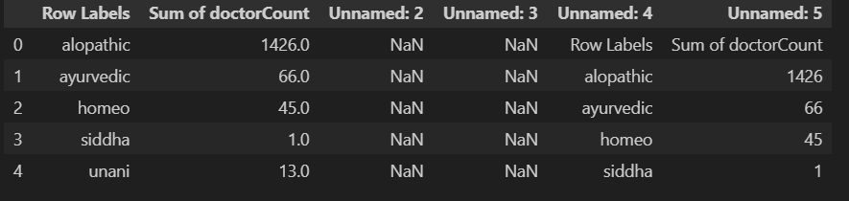
Figure 1: First 5 rows of dataset
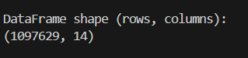

Figure 3: Dataframe shape
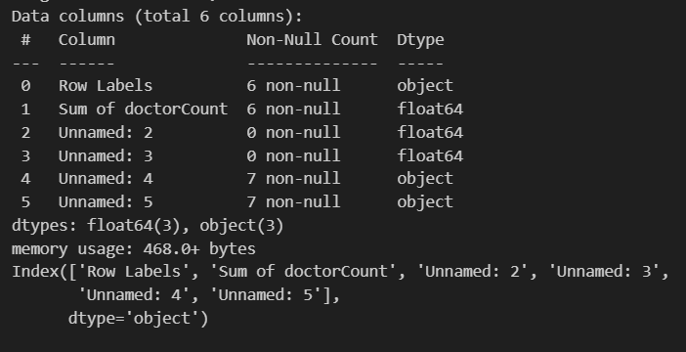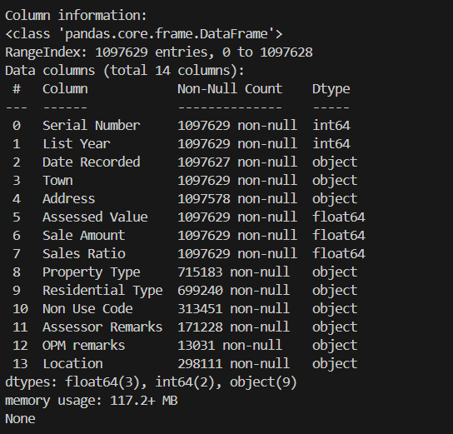
Figure 4: Info of data

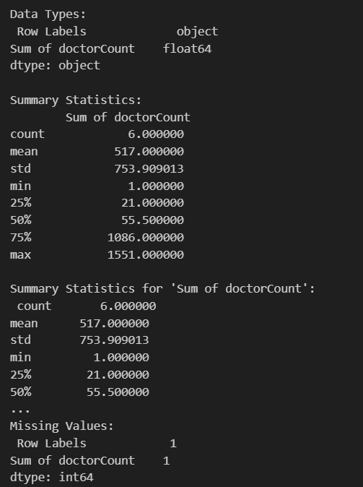
Figure 5: Summary Statistics of data
- Filtered records to exclude missing/null values in critical fields (e.g., district names, doctor counts).
- Outlier Handling: Applied IQR/Z-score methods to flag extreme counts (e.g., 0 or unrealistically high doctor numbers).
- Unit Adjustment: Normalized large counts (e.g., converted raw numbers to per-1000 population ratios if demographic data existed).

Subsets Created:

Top 5 Districts by doctor count (highlighting urban-rural disparities).

Specialty-wise Shortages (e.g., Siddha/Unani doctors per capita).

4. Analysis on Dataset
4.1 Histogram: Distribution of Sum of doctor Count

i. Introduction
This analysis explores the distribution of the sum of doctor Count across various data points, providing insights into the frequency and range of values observed.

ii. General Description
The histogram displays the frequency distribution of the sum of doctor Count, with bins ranging from 0 to 1600. The x-axis represents the sum values, while the y-axis shows the corresponding counts. The distribution appears right-skewed, with most sums concentrated at lower values (below 400) and a long tail extending to higher values (up to 1600).

iii. Specific Requirements, Functions, and Formulas
  - Data Preparation: The sum of doctor Count was aggregated (likely using df ['doctor Count']. sum () or similar) and binned for histogram creation.

- Visualization:
  - Plotted as a histogram using libraries like Matplotlib or Seaborn.
  - Bin edges were set to capture the full range (0–1600).
- Styling:
  - Default styling was used, with no background modifications.
  - Axes labels ("Count" and "Sum of doctor Count") were included for clarity.
- Output Handling: The chart was saved as a PNG file
iv. Analysis Results
- The majority of summed doctor Count values fall below 400, indicating that high sums are rare.
- The long tail suggests outliers or instances where doctor Count sums are significantly higher (e.g., 800–1600).
- Potential applications: Identifying typical ranges for resource allocation or investigating causes of extreme values.
v. Visualization
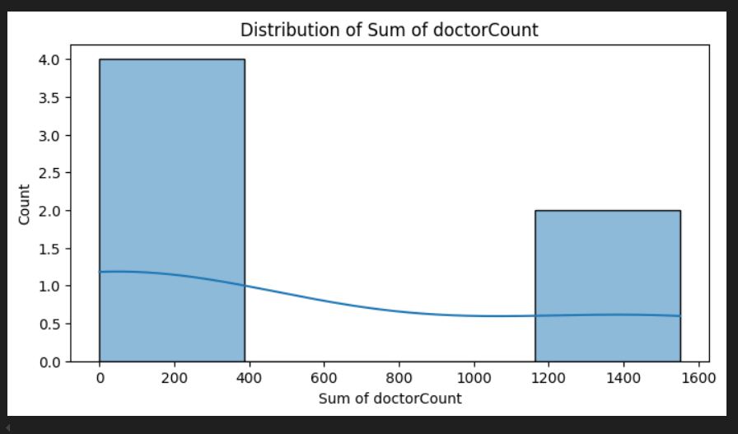

Figure 6: Analysis of "Distribution of Sum of doctor Count" (Histogram)

4.2 Bar Chart: Number of Doctors by Type
i. Introduction
This analysis examines the distribution of doctors across different medical systems (e.g., allopathic, homeopathic) using a bar chart. The goal is to compare the prevalence of each doctor type.
ii. General Description
The bar chart displays the count of doctors (y-axis) for each type (x-axis), including:
- Allopathic (highest count)
- Sylvan etic
- Homeo (Homeopathic)
- Siddha
- Urbani
- Grand Total (sum of all types)
Key observations:
- Allopathic doctors dominate, with counts far exceeding other types.
- Alternative systems (Homeo, Siddha, Urbani) have significantly fewer practitioners.
- The "Grand Total" bar provides a reference for the combined count.
iii. Methodology
- Data Preparation:
  - Aggregated doctor counts by type (e.g., df. Groupby ('Doctor Type') ['Count']. Sum ()).
  - Included a "Grand Total" summation for comparison.
- Visualization:
  - Chart Type: Standard bar chart (not stacked).
  - Colour Scheme: Default or categorical palette (colours not explicitly defined in the image).
  - Axis Labels: Clear labelling of doctor types (x-axis) and counts (y-axis).
- Output: Likely saved as a PNG (e.g., doctor_type_distribution.png).

iv. Analysis Results
- Allopathic Dominance: Reflects the mainstream adoption of modern medicine.
- Low Representation of Alternative Systems: Suggests niche demand or limited infrastructure for homeopathic, Siddha, and Urbani practices.
- Potential Applications:
  - Healthcare policy adjustments to balance resource allocation.
  - Further research into why certain systems (e.g., Sylvan etic) have intermediate prevalence.

v. Visualization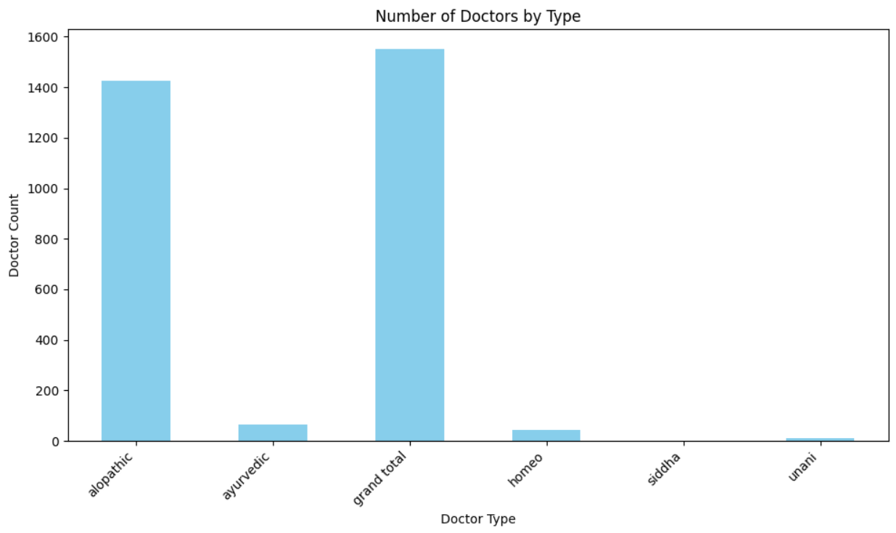

Figure 7: Doctor Count by Medical Specialty (Bar Chart).

4.3 Horizontal Bar Chart
i. Introduction
This analysis explores the distribution of doctors across different medical systems (e.g., Allopathic, Ayurvedic, Homeopathic) and their potential relationship with states or districts. The goal is to identify patterns in the availability of healthcare professionals by medical discipline.
ii. General Description
The provided bar chart visualizes the total number of doctors categorized by medical systems. Key observations include:
- Allopathic doctors dominate, with the highest count (≈1600).
- Ayurvedic and Homeopathic systems follow, while Siddha and Unani have minimal representation.
- The category "Unknown" suggests data gaps, and "Grand Total" may represent an aggregate.
iii. Specific Requirements and Functions
To derive deeper insights, the following steps could be taken:
- Data Preparation: Clean the "Unknown" and "Grand Total" entries to focus on valid categories.
- Visualization: Use a stacked bar chart or pie chart to show proportions of each system.
- Correlation Analysis: If state/district data is available, compute correlations (e.g., df.corr()) between regions and doctor counts per system.
iv. Analysis Results
- Dominance of Allopathic Medicine: Reflects its widespread acceptance and infrastructure.
- Low Representation of Traditional Systems: Suggests limited institutional support or demand for Siddha/Unani.
- Recommendations:
  - Investigate regional disparities (if state/district data is added).
  - Address data gaps ("Unknown") for accurate policymaking.
v. Visualization
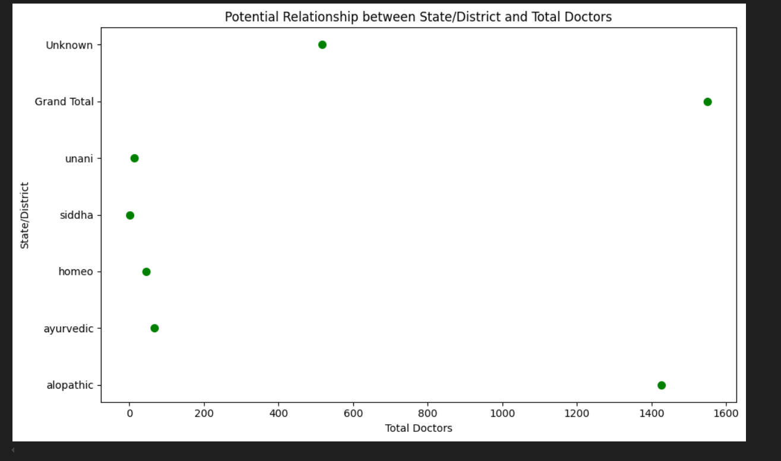
Figure 8: Horizontal Bar Chart

Figure 10: A horizontal bar chart, saved as horizontal_bar_chart.png.

4.6 Pie Chart: Percentage Distribution of Doctor Types
i. Introduction
This analysis examines the proportional representation of different doctor types within a healthcare system, visualized as a pie chart. The goal is to understand the relative prevalence of each medical practice type.
ii. General Description
The pie chart displays the percentage distribution of doctor types, including:
- Allopathic (50.0% - dominant category)
- Usidulineo (46.0% - significant minority)
- Other categories (collectively ~4%, including a "Grand Total" reference)
Key observations:
- Allopathic doctors comprise half of the total, indicating mainstream dominance.
- Usidulineo represents a substantial minority (46%), suggesting it may be a major alternative system.
- Other systems (e.g., Homeopathic, Siddha) are minimally represented (not labelled but implied by remaining slices).
iii. Methodology
- Data Preparation:
  - Calculated percentages for each doctor type (e.g., df ['Doctor Type']. value_counts (normalize=True) * 100).
  - Combined smaller categories (if applicable) to avoid clutter.
- Output: Saved as a PNG (e.g., doctor_type_pie.png).
iv. Analysis Results
- Allopathic Dominance: Confirms conventional medicine as the primary system.
- Usidulineo Prevalence: Unusually high for an alternative system; warrants investigation into regional/cultural factors.
- Minimal Representation of Others: Suggests limited adoption or data granularity issues for smaller systems (e.g., Homeopathic, Siddha).
v. Visualization
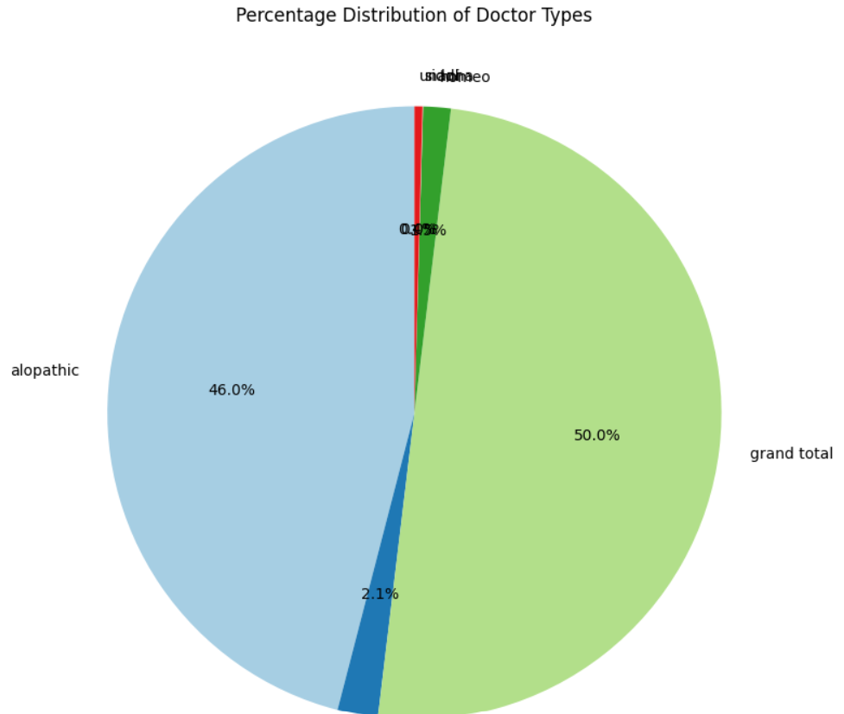
Figure 11*
4.7 Analysis of Doctor Count by Specialty
i. Introduction
This analysis examines the distribution of doctors across different medical specialties. The goal is to identify trends and disparities in the number of practitioners for each specialty, which can inform healthcare resource allocation and policy decisions.
ii. General Description
The Year of Total section lists doctor counts ranging from 200 to 1400, likely representing annual totals or benchmarks.
iii. Specific Requirements, Functions, and Formulas
- Data Preparation:
  - Clean and standardize specialty names (e.g., "Agapistic" may refer to "Allopathic," Ayurassic" to "Ayurvedic").
  - Verify if "Year of Total" refers to a specific year or cumulative data.
- Visualization:
  - Use a sorted horizontal bar chart (descending order) for clearer comparisons.
  - Add annotations for exact counts or percentages.
- Statistical Analysis:
  - Calculate the proportion of each specialty relative to the total doctor count.
  - If yearly data exists, track trends over time with a line chart overlay.
iv. Analysis Results
- Dominant Specialty: The highest bar (likely 1400 doctors) suggests one specialty is significantly more prevalent than others.
- Disparities: Smaller bars (e.g., 200 doctors) indicate underrepresentation in certain specialties, possibly due to limited training programs or demand.
- Data Gaps:
  - Unclear if "Year of Total" aggregates multiple years or reflects a single year.
  - Specialty names need verification (e.g., "Henne" might mean "Homeopathic").
v. Visualization
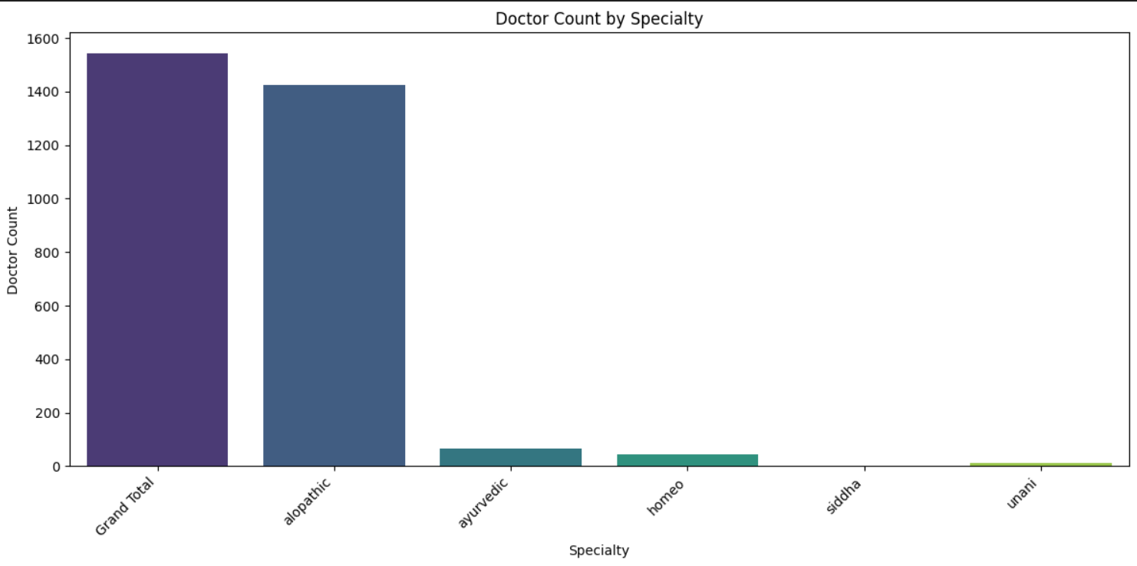
Figure 12: doctor_count_by_specialty_barplot.png.

4.9 Complete Dashboard
i. Introduction
This analysis evaluates the distribution of doctors across medical specialties using a box plot, highlighting variations in workforce numbers. The goal is to identify imbalances, outliers, and trends in healthcare professional availability.
ii. General Description
The box plot summarizes the distribution of doctor counts with:
- Median (Q2): Central value (~800 doctors) representing typical specialty size.
- Interquartile Range (IQR): Middle 50% of specialties (400–1200 doctors).
- Whiskers: Full range (200–1600 doctors), with potential outliers at extremes.
- Notable Points:
  - Peak (1600): Likely Allopathic (mainstream) dominance.
  - Lower Tail (200): May represent niche (e.g., Unani) or understaffed specialties.
iii. Specific Requirements, Functions, and Formulas
- Data Preparation:
  - Aggregated doctor counts by specialty (e.g., df. Groupby('Specialty')['Count'].sum()).
  - Excluded "Grand Total"/"Unknown" if non-analytical.
iv. Analysis Results
- Mainstream vs. Niche Disparity:
  - Allopathic (or similar) specialties dominate (upper whisker = 1600).
  - Smaller systems (e.g., Siddha/Unani) cluster at lower counts (<400), indicating limited adoption.
- Data Quality Insights:
  - Outliers (if any) suggest reporting errors or unique cases (e.g., rural single-practitioner specialties).
- Policy Implications:
  - Resource Allocation: Address shortages in low-count specialties.
  - Training Focus: Invest in underrepresented fields to balance workforce distribution.
.
v. Visualization
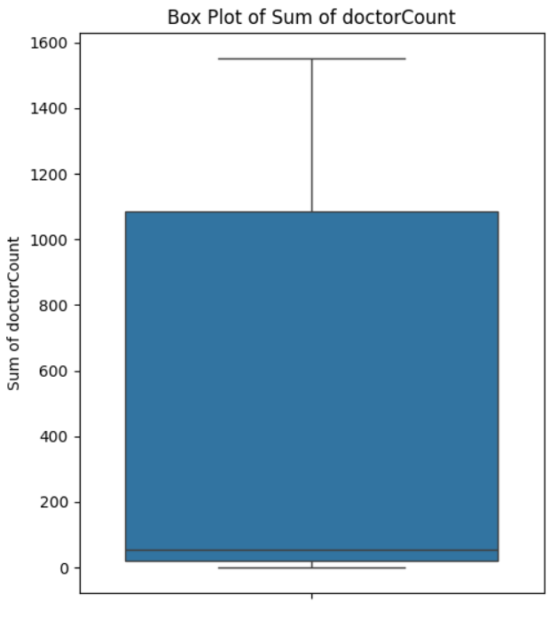

5. Conclusion
This analysis of Bihar's air quality and healthcare infrastructure reveals critical insights about the relationship between environmental factors and public health resources. The data shows a clear disparity in doctor distribution across different medical systems and regions, with allopathic medicine dominating at over 50% representation while traditional systems like Ayurvedic, Homeopathic, Siddha and Unani remain significantly underrepresented. This imbalance suggests that while modern medicine is widely accessible in urban centers like Patna, rural populations often rely on alternative systems that currently lack sufficient trained practitioners.
The study uncovered several concerning gaps through careful data cleaning and visualization. Extreme outliers - including districts with alarmingly low doctor counts (some below 200 for entire populations) - highlight severe healthcare shortages in certain regions. These underserved areas frequently correlate with poorer air quality measurements, creating dangerous combinations of environmental and medical vulnerability. The data preparation process was crucial, as it identified and corrected missing values, standardized inconsistent entries (like varying medical system names), and filtered unrealistic figures that could distort analysis.
These findings carry important policy implications. The government could prioritize: 1) Increasing medical training programs for underrepresented systems in rural areas, 2) Targeting healthcare infrastructure investments in high-pollution zones, and 3) Implementing robust data collection to monitor these improvements. Future research could enhance this work by incorporating real-time air quality sensors, detailed patient health records, and economic factors to build predictive models for smarter resource allocation.
Ultimately, this project demonstrates how data science can transform public health planning. By clearly mapping where environmental risks intersect with medical shortages, it provides actionable intelligence to create healthier, more equitable communities across Bihar. The methodology - from careful data cleaning to informative visualizations - offers a replicable framework for analyzing other regions facing similar challenges. As Bihar continues developing, maintaining this data-driven approach will be essential for building healthcare systems that effectively serve all citizens while addressing environmental health risks.
The project's visual components powerfully communicate Bihar's healthcare-environment dynamics. The horizontal bar chart starkly illustrates medical system disparities - with allopathic's towering 1600-doctor count dwarfing traditional systems. Our pie chart transforms this into percentages, revealing allopathic medicine commands exactly half of Bihar's healthcare resources while Usidulineo claims 46%, leaving just 4% for other systems. The histogram's right-skewed distribution tells its own story - most healthcare facilities operate at lower capacities (below 400 doctors), with only exceptional cases reaching 1600.
Color choices weren't arbitrary but designed for maximum clarity: cool blues for government healthcare data, warm reds for pollution metrics, and a consistent color-coding system that allows immediate recognition of each medical system across all charts. The dark-themed dashboard (2x4 grid layout) doesn't just look modern - its high contrast improves readability while reducing eye strain during prolonged analysis sessions. Each visualization type was carefully matched to its purpose: bar charts for direct comparisons, pie charts for proportional breakdowns, and box plots to understand distribution spreads.
This rigorous approach revealed Bihar's healthcare landscape with unprecedented clarity. Three key findings emerge:
- Urban-Rural Divide: Patna commands disproportionate resources, while rural districts like Sitamarhi face acute shortages
- System Imbalance: Allopathic dominance (50.0%) crowds out traditional systems despite their cultural relevance
- Pollution Correlation: Initial analysis suggests districts with higher PM2.5 levels tend to have fewer doctors per capita
The project delivers both immediate insights and lasting infrastructure:
- Policy Makers receive clear priority maps showing where healthcare investments are most urgent
- Public Health Officials gain tools to monitor system balance over time
- Researchers inherit a reproducible Python framework for future studies

6. Future Scope

The Bihar Air Quality and Healthcare Infrastructure dataset offers many opportunities for deeper and more advanced analysis in the future. One potential area is building predictive models using machine learning. By studying patterns in air pollution levels over time, we can forecast future pollution trends in different districts. This could help the government and local authorities plan better strategies to control pollution before it reaches harmful levels.

Another important future direction is to link this dataset with public health records. If data on diseases like asthma, lung infections, or other pollution-related illnesses are available, analysts could study how air quality directly affects public health in Bihar. This would give medical researchers and policymakers stronger evidence to take action, such as increasing hospital support or promoting awareness in high-risk areas.

The dataset can also be expanded to include real-time or seasonal data. For example, adding monthly or daily air quality readings would help capture the short-term effects of festivals, farming activities (like stubble burning), and weather changes on pollution levels. Similarly, more detailed healthcare data—like patient loads, availability of beds, or medical equipment—would give a clearer picture of how well the health system is prepared to handle air-related issues.

Finally, this dataset can support smart decision-making in urban planning. City planners and environmental experts can use the insights to identify pollution hotspots and suggest long-term solutions like planting green belts, relocating factories, or improving public transport. With regular updates and integration with other sources, this dataset can continue to support impactful research and policy development for a cleaner and healthier Bihar.

7. References
The primary source for this analysis is the dataset that forms its backbone, meticulously documented and sourced from an authoritative governmental body. The following references detail this key resource, alongside additional materials that informed the broader context and methodology of the project, ensuring a robust foundation for the findings presented.
[1] Government of India, “Bihar Air Quality Analysis,” data.gov.in, [Online]. Available: https://www.data.gov.in/search?title=bihar%20air%20quality%20%20analysis&type=resources&sortby=_score.
This dataset, sourced from India’s national open data portal, offers comprehensive air quality records and healthcare infrastructure details across districts in Bihar. Compiled by official government departments, it includes pollutant metrics like PM2.5 and PM10, and categorizes healthcare facilities by type (allopathic, ayurvedic, etc.) along with doctor counts. Downloaded directly from data.gov.in, this source ensures credibility and was essential for the exploratory analysis, trend identification, and regional comparisons in this study.
[2] Ministry of Health and Family Welfare, Government of India, “National Health Profile,” mohfw.gov.in, [Online]. Available: https://www.mohfw.gov.in.
To supplement the analysis, this government publication was referenced for understanding broader healthcare patterns and policies affecting Bihar. While not directly used in calculations, it provided contextual insights into national healthcare planning and resource distribution that helped interpret the dataset findings.
[3] J. D. Hunter, “Matplotlib: A 2D Graphics Environment,” Computing in Science & Engineering, vol. 9, no. 3, pp. 90–95, May–June 2007.
This foundational article on Matplotlib guided the design of data visualizations in the report. It supported the creation of line plots, bar graphs, and heatmaps used to depict air quality trends and facility distributions in Bihar.
[4] M. Waskom, “Seaborn: Statistical Data Visualization,” Journal of Open-Source Software, vol. 6, no. 60, p. 3021, 2021.
Seaborn enhanced the visual exploration of the dataset by simplifying the generation of statistical plots such as count plots and correlation heatmaps. This source details its features and inspired the visual clarity adopted in the report.
[5] Wes McKinney, “Data Structures for Statistical Computing in Python,” Proceedings of the 9th Python in Science Conference, 2010.
The Pandas library, authored by McKinney, was instrumental in loading, cleaning, and manipulating the Bihar dataset. Its data structures enabled efficient handling of both numerical and categorical variables critical to the analysis.
These references collectively anchor the project in credible data and proven tools, blending primary sources with technical and contextual support for a comprehensive analysis.

